

Mini Project Report
On

Smart Route Finder using Shorting Path Algorithms

SUBMITTED BY: SUBMITTEDTO:
Ayush Thakur Mr.Shubham Sharma
UID: 26MCI10311 AssistantProfessor
CLASS: MCA (AI&ML)
Course Code: E20414
SECTION: 26MAM5(B)

Table ofContent

S.No. | Name | Page no.
Chapter 1 | Introduction/Background | 4
Chapter 2 | Objective/ Technologies Used | 4
Chapter 3 | Technologies Used | 4
Chapter 4 | Requirements and System Design | 5-6
Chapter 5 | Source Code & Output | 7-12
Chapter 6 | Functionalities | 13
Chapter 7 | Conclusion/Future Work/ Learning Out comes | 14

DECLARATION

I, Ayush Thakur, student of MCA (AI & ML) at Chandigarh University, hereby declare that the

mini-project entitled “Smart Route Finder” has been prepared and submitted by me as part of my

academic work. I declare that the information presented in this report is true to the best of my knowledge. The project work has been carried out for academic purposes under the guidance of Mr. Shubham Sharma, Assistant Professor. Any external resources, references, or assistance used in preparing this project should be appropriately acknowledged.

I understand that I am responsible for ensuring the originality and accuracy of the submitted work

and for following the university's academic integrity guidelines.

Student Signature: ________

Name: Ayush Thakur (UID: 26MCI10311)

Date: ________

ACKNOWLEDGEMENT

I would like to express my sincere gratitude to Mr. Shubham Sharma, Assistant Professor, for his

valuable guidance, support, and encouragement throughout the development of my mini-project

entitled “Smart Route Finder.” I am thankful to Chandigarh University for providing me with the opportunity and resources to undertake this project as part of my MCA (AI & ML) course. This project helped me gain practical knowledge of Python programming, graph data structures, and shortest-path algorithms.I would also like to thank my teachers, classmates, and everyone who directly or indirectly supported me in completing this project successfully.

Finally, I am grateful for the opportunity to apply my theoretical knowledge to a practical problem and improve my programming and problem-solving skills.

Thank you

CHAPTER 1: INTRODUCTION

1.1 Introduction:

Smart Route Finder is a software application designed to find the shortest or most suitable route between a starting location and a destination. It uses graph data structures and algorithms to calculate routes based on the distance or cost associated with each road or connection.

In today's world, route-finding systems are useful in transportation, navigation, delivery services, and travel planning. Finding an efficient route helps users reduce unnecessary travel and compare different paths between locations.

1.2 Background of the Project:

Route-finding is an important problem in computer science because many real-world situations involve selecting an

efficient path from one point to another. Traditional methods of selecting routes may require users to compare

multiple roads and distances manually.

Graph algorithms provide an effective way to solve this problem. In a graph, locations are represented as vertices,

while roads or connections are represented as edges. Each edge can have a weight representing distance, travel

time, or cost.

Smart Route Finder applies these concepts to a simple route-finding system. The project uses Python to store the

graph and process the connections. Dijkstra's algorithm explores possible paths and identifies a route with the

minimum total weight.

This project provides practical knowledge of graph representation, algorithm implementation, problem-solving, and computational efficiency.

1.3 Problem Statement:

Finding the shortest route between two locations can be challenging when several alternative paths are available. Selecting a route manually may take additional time and can lead to an inefficient choice.

The problem addressed by Smart Route Finder is to design a program that accepts a source and destination, processes the available connections, and determines the route with the minimum total distance or cost.

The system aims to provide a simple and efficient solution using graph data structures and Dijkstra's algorithm. The basic implementation uses predefined locations and distances rather than live GPS or real-time traffic information.

1.4 Need for the Project:

The Smart Route Finder project is useful for understanding how algorithms can solve route-selection problems. Its main needs are:

1. To find a shortest path between two locations.

2. To reduce the effort required to compare possible routes manually.

3. To calculate the total distance or cost of a selected route.

4. To demonstrate the use of graph data structures.

5. To implement Dijkstra's algorithm using Python.

6. To improve programming and logical problem-solving skills.

7. To understand the role of algorithms in navigation and transportation systems.

1.5 Scope of the Project:

The scope of Smart Route Finder includes the design and implementation of a basic shortest-path system using Python. The program stores locations and their connections in a weighted graph and calculates the minimum-cost route between a selected source and destination.

The current version supports predefined locations, distance-based route calculation, route display, and basic input validation.

In the future, the project can be enhanced by integrating real map data, GPS coordinates, an interactive graphical interface, traffic information, and mobile application support. These enhancements could make the system more practical for real-world navigation.

CHAPTER 2: OBJECTIVES OF PROJECT

2.1 Introduction:

The objectives of the Smart Route Finder project describe the main goals and expected outcomes of the system. The project focuses on finding an efficient route between a source location and a destination using graph algorithms and Python programming.

It aims to apply the theoretical concepts of Design and Analysis of Algorithms (DAA) to a practical route-finding problem.

2.2 Main Objectives:

The main objectives of this project are:

1. To develop a simple route-finding application using Python.

2. To represent locations and connections using a graph data structure.

3. To implement Dijkstra's algorithm for shortest-path calculation.

4. To calculate the total distance or cost of a selected route.

5. To accept source and destination locations from the user.

6. To display the selected route in a clear format.

7. To validate user input and handle invalid locations.

8. To understand the practical use of algorithms in navigation systems.

2.3 Aim of Smart Route Finder:

The main aim of Smart Route Finder is to identify the route with the minimum total distance or cost between two locations in a weighted graph.

The system uses predefined locations and connections. Each connection has a weight representing

the distance between two locations. The algorithm compares available paths and returns a

minimum-cost route when a valid path exists.

This approach helps demonstrate how computer algorithms can solve route-selection problems

efficiently.

2.4 Purpose of the System:

The purpose of the Smart Route Finder system is to provide a simple and understandable solution

to the shortest-path problem.

The system is designed to:

- Reduce manual effort in comparing possible routes.

- Calculate the total distance of a route.

- Demonstrate graph traversal and shortest-path calculation.

- Provide practical experience in Python programming.

- Improve understanding of algorithm design and analysis.

- Build a foundation for future navigation applications.

2.5 Expected Outcomes:

After completing the project, the expected outcomes are:

1. A working Python program for finding the shortest route.

2. Correct representation of locations using a weighted graph.

3. Successful implementation of Dijkstra's algorithm.

4. Display of the route from source to destination.

5. Calculation of the minimum total distance for the given graph.

6. Basic validation of source and destination inputs.

7. Better understanding of time complexity and algorithm efficiency.

8. Practical knowledge of applying DAA concepts to real-world problems.

2.6 Applications of the Project:

Smart Route Finder demonstrates concepts that can be applied in several areas:

1. Transportation and road navigation.

2. Delivery and logistics planning.

3. Travel route comparison.

4. Network routing and connectivity.

5. Educational demonstrations of graph algorithms.

6. Planning paths through connected locations.

The current academic version uses a predefined graph. Real-world applications would require

suitable map data, accurate distances, and additional features.

2.7 Summary:

This chapter presented the objectives, aim, purpose, expected outcomes, and applications of

the Smart Route Finder project. The system focuses on using Python, weighted graphs, and

Dijkstra's algorithm to calculate a minimum-cost route. These objectives provide the

foundation for the technologies and system design discussed in the next chapter.

CHAPTER 3: TECHNOLOGIES USED

3.1 Introduction:

The Smart Route Finder project uses programming tools, data structures, and algorithms to

calculate the shortest route between two locations. Python is used to implement the program, while

a graph data structure represents the locations and their connections.

Dijkstra's algorithm is used to find the minimum-distance path in a graph with non-negative edge

weights. Visual Studio Code (VS Code) provides an environment for writing, executing, and

testing the program.

3.2 Python Programming Language:

Python is a high-level, interpreted programming language known for its simple syntax and readability. It is widely used in software development, data analysis, artificial intelligence, and algorithm implementation.

In the Smart Route Finder project, Python is used to:

- Store locations and road connections.

- Accept source and destination inputs.

- Implement the shortest-path algorithm.

- Calculate the total distance of a route.

- Display the final route and result.

Python makes the project easy to understand, develop, test, and maintain.

3.3 Graph Data Structure:

A graph is a non-linear data structure consisting of vertices and edges. Vertices represent locations, while edges represent connections between those locations.

In Smart Route Finder:

- Vertices (nodes): Represent locations such as A, B, C, and D.

- Edges: Represent roads or connections between locations.

- Weights: Represent distances or costs associated with connections.

The project uses a weighted graph to store the available routes. Python dictionaries are used to represent the graph and store the weights of connections.

For example, a connection from A to B with a weight of 4 represents a distance or cost of 4 units.

3.4 Dijkstra's Algorithm:

Dijkstra's algorithm is a graph algorithm used to find the shortest path from a starting vertex to

other vertices in a graph with non-negative edge weights. The algorithm works by maintaining the

shortest known distance to each location. It repeatedly selects the unprocessed location with the

smallest known distance and updates the distances to its neighbouring locations.

The main steps are:

1. Set the distance of the source location to zero.

2. Set the initial distances of other locations to infinity.

3. Select the unprocessed location with the smallest known distance.

4. Examine its neighbouring locations.

5. Update a neighbour's distance if a shorter path is found.

6. Repeat until the destination is reached or no reachable locations remain.

7. Reconstruct and display the shortest path.

Dijkstra's algorithm is suitable for this project because the route connections use non-negative distances.

3.5 Visual Studio Code (VS Code):

Visual Studio Code is a source-code editor used to write and manage programming files. It supports Python development through extensions and an integrated terminal.

In this project, VS Code is used to:

- Create the Python source file.

- Write and edit the program.

- Execute the code in the terminal.

- Identify and correct syntax errors.

- Test different source and destination inputs.

It provides a convenient environment for developing and testing the Smart Route Finder application.

3.6 Python Libraries Used:

The project uses Python's built-in "heapq" module to manage a priority queue. This allows the program to process the location with the smallest accumulated distance efficiently.

The main library and language features are:

1. heapq: Provides heap-based priority queue operations used by Dijkstra's algorithm.

2. Dictionaries: Store the graph and the weights of connections between locations.

3. Lists: Store the calculated route and its sequence of locations.

4. Sets: Track locations that have already been processed

Matplotlib may be added if the project includes a graphical representation of the graph or

route. It is optional and is not required for the basic console-based implementation.

3.7 System Requirements:

The basic project can be developed using the following setup:

Hardware Requirements

- Computer or laptop.

- Keyboard and mouse.

- Sufficient memory and storage to run Python and the code editor.

Software Requirements

- Windows, Linux, or macOS.

- Python 3.

- Visual Studio Code or another Python-compatible editor.

- Python's built-in "heapq" module.

The basic program does not require an internet connection because it uses predefined graph data rather than live map services.

3.8 Algorithm Complexity:

Algorithm complexity measures the time and memory required as the input size increases.

For the implementation using an adjacency list and a heap-based priority queue, Dijkstra's algorithm typically has a time complexity of:

Time Complexity: O((V + E) log V)

Here, V represents the number of vertices and E represents the number of edges.

The graph storage requires O(V + E) space. The algorithm also uses additional space for the priority queue, visited set, and stored paths.

Understanding complexity helps evaluate the efficiency of the route-finding system.

3.9 Summary:

This chapter explained the technologies used in the Smart Route Finder project, including Python,

graph data structures, Dijkstra's algorithm, Visual Studio Code, and the "heapq" module. These

technologies work together to represent locations, calculate minimum-cost paths, and display route

results. The next chapter describes the system requirements and design.

CHAPTER 4: REQUIREMENTS AND SYSTEM DESIGN

4.1 Introduction:

System design describes the structure, components, and working process of the Smart Route Finder application. It explains how the user provides input, how the graph stores locations and connections, and how the algorithm calculates the shortest route.

4.2 Hardware Requirements:

The hardware requirements specify the basic equipment needed to develop and run the project.

The requirements are:

1. A desktop computer or laptop.

2. A keyboard and mouse.

3. Sufficient RAM to run Python and Visual Studio Code.

4. Available storage for the source code and project files.

5. A display screen to view the code and program output.

The project does not require specialized hardware because it uses a basic graph algorithm and predefined data.

4.3 Software Requirements:

The software requirements include the operating system, programming language, and

development environment needed to run the project.

The software requirements are:

1. Operating System: Windows, Linux, or macOS.

2. Programming Language: Python 3.

3. Code Editor: Visual Studio Code.

4. Algorithm: Dijkstra's shortest-path algorithm.

5. Python Module: "heapq" for priority queue operations.

6. Terminal: Used to execute the Python program.

The basic version does not require an external database or an internet connection because the graph is stored directly in the Python program.

4.4 Functional Requirements:

Functional requirements describe the operations that the Smart Route Finder system must perform.

The main functional requirements are:

1. Accept a source location from the user.

2. Accept a destination location from the user.

3. Store locations and connections in a weighted graph.

4. Calculate the shortest route using Dijkstra's algorithm.

5. Calculate the total distance or cost of the selected route.

6. Display the route and its total distance.

7. Validate source and destination inputs.

8. Display an appropriate message for invalid locations or unavailable routes.

These functions allow the user to test route calculations with the predefined graph.

4.5 System Architecture:

The system architecture explains how the different components work together to produce

the final result.

The Smart Route Finder system contains four main components:

1. Input Module: Receives the source and destination from the user.

2. Graph Module: Stores locations, connections, and their weights.

3. Algorithm Module: Applies Dijkstra's algorithm to find the shortest route.

4. Output Module: Displays the selected route and its total distance.

System Architecture Diagram

User Input → Graph Representation → Dijkstra's Algorithm → Route Calculation → Output Display

The input module passes the selected locations to the algorithm. The algorithm uses the graph data to calculate the minimum-cost route, and the output module displays the result.

4.6 Flowchart of the System:

A flowchart represents the sequence of operations performed by the program.

Steps in the flowchart

1. Start the program.

2. Load the predefined graph.

3. Enter the source and destination.

4. Check whether both locations are valid.

5. If the input is invalid, display an error message.

6. Otherwise, execute Dijkstra's algorithm.

7. Check whether a route exists.

8. If a route exists, display the path and total distance.

9. Otherwise, display a message that no route is available.

10. End the program.

Text Flowchart

START

↓

Load Graph

↓

Enter Source and Destination

↓

Are Both Locations Valid?

↓

If No → Display Invalid Input Message → END

↓ If Yes

Run Dijkstra's Algorithm

↓

Is a Route Available?

↓

If Yes → Display Shortest Route and Distance

↓

If No → Display No Route Found

↓

END

4.7 Graph Representation:

A graph is used to represent the locations and connections available in the system.

The graph consists of:

- Vertices: Locations such as A, B, C, and D.

- Edges: Connections between locations.

- Weights: Distances or costs assigned to the connections.

The project uses an adjacency-list representation implemented with Python dictionaries.

For example:

graph = {

"A": {"B": 4, "C": 2},

"B": {"A": 4, "C": 1, "D": 5},

"C": {"A": 2, "B": 1, "D": 8},

"D": {"B": 5, "C": 8}

}

In this graph, the connection from A to B has a weight of 4, while the connection from A to C has a weight of 2. The weights represent illustrative distances in kilometres.

This representation makes it possible to store and access the neighbouring locations efficiently.

4.8 Algorithm Design:

The system uses Dijkstra's algorithm to calculate the shortest path between two locations.

Algorithm

Input: A weighted graph, source location, and destination location.

Output: The shortest route and its total distance, if a route exists.

Procedure:

1. Initialize the source distance to zero.

2. Insert the source into a priority queue.

3. Remove the location with the smallest known distance.

4. Skip the location if it has already been processed.

5. Examine each neighbouring location.

6. Calculate the distance through the current location.

7. Update the neighbour's distance if the new distance is smaller.

8. Store the path information needed to reconstruct the route.

9. Continue until the destination is reached or no reachable locations remain.

10. Display the route and its total distance.

Dijkstra's algorithm requires non-negative edge weights. It is suitable for the weighted graph used in this project.

4.9 Non-Functional Requirements:

Non-functional requirements describe the quality and performance expected from the system.

The main non-functional requirements are:

1. Simplicity: The program should be easy to understand and use.

2. Efficiency: The algorithm should calculate routes efficiently.

3. Reliability: The program should produce correct results for valid inputs and graph data.

4. Maintainability: The code should be organized so that changes can be made easily.

5. Portability: The program should run on systems that support Python 3.

6. Usability: The output should clearly display the selected route and distance.

4.10 Summary:

This chapter described the hardware and software requirements, functional and non

functional requirements, system architecture, flowchart, graph representation, and

algorithm design of Smart Route Finder.The system uses a weighted graph to represent locations and Dijkstra's algorithm to calculate the minimum-distance route. The next chapter presents the implementation, source code, sample inputs, outputs, and complexity analysis.

CHAPTER 5:SOURCE CODE AND OUTPUT

Source Code:

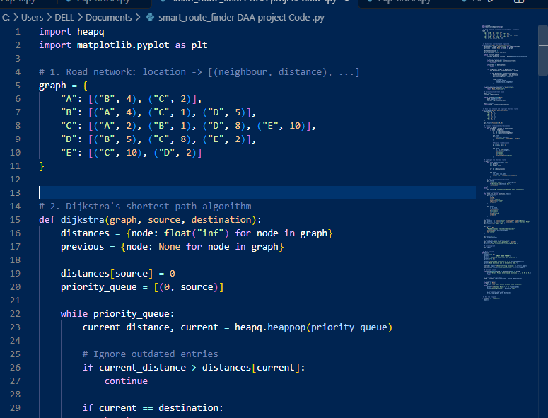

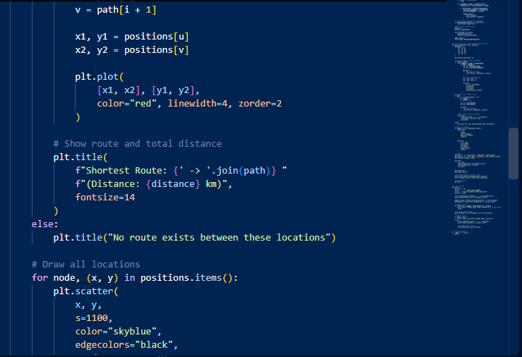

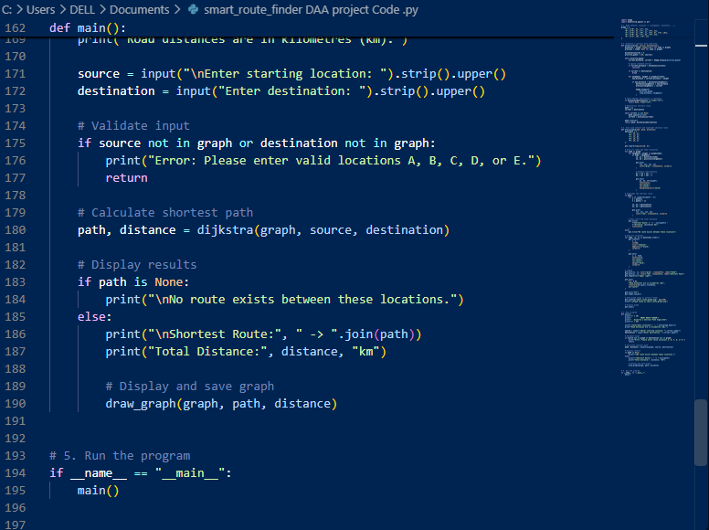

Output :

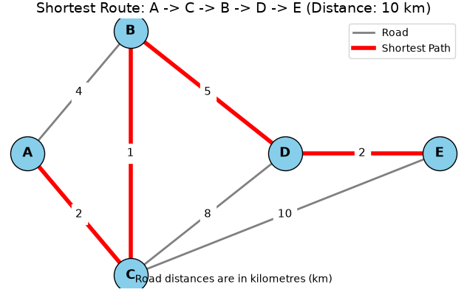

CHAPTER 6: FUNCTIONALITIES

6.1 Introduction:

The functionalities of Smart Route Finder describe the main features and operationsprovided by the application. The system is developed using Python and applies graph datastructures and Dijkstra's algorithm to find a minimum-distance route between two locations. The application accepts source and destination locations, processes the available connections calculates the shortest route, and displays the result. These functionalities demonstrate the practical use of Design and Analysis of Algorithms (DAA) in solving route-finding problems.

6.2 Source Location Selection:

Source location selection allows the user to specify the starting point of the journey. The

program accepts the source as input and checks whether it exists in the predefined graph.

For example, the user can enter location A as the starting point. The algorithm begins its

route calculation from this location.

This feature helps the system identify where the journey starts.

6.3 Destination Location Selection:

Destination location selection allows the user to specify the final location of the journey.

For example, if the user enters D as the destination, the system attempts to find the route

from the selected source to location D. The program checks whether the destination

exists in the graph before executing the shortest-path calculation.

6.4 Shortest Route Calculation:

Shortest route calculation is the main functionality of the Smart Route Finder application.

The system uses Dijkstra's algorithm to find the route with the minimum total weight

between the source and destination. It examines available connections and selects a path

with the lowest accumulated distance.

For example, the shortest route from A to D in the sample graph is:

A → C → B → D

The algorithm calculates the total distance by adding the weights of the connections in the selected route.

6.5 Distance Calculation:

The distance calculation feature determines the total distance of the selected route.

For the route A → C → B → D, the distances are:

- A to C = 2 km

- C to B = 1 km

- B to D = 5 km

Total distance = 2 + 1 + 5 = 8 km

The system displays the calculated total so that the user can understand the cost of travelling along the selected path. The distances used in this academic project are illustrative values, not actual road distances.

6.6 Input Validation:

Input validation checks whether the source and destination entered by the user are valid

locations in the graph.

For example, the program accepts A, B, C, or D. If the user enters an unknown location

such as X, the program displays an invalid-location message.

This feature helps prevent errors caused by unsupported inputs and makes the application

easier to use.

6.7 Route Display:

The route display functionality presents the calculated route in a readable format.

For example, the program displays:

Shortest route: A -> C -> B -> D

Total distance: 8 km

The output allows the user to identify the sequence of locations and the total distance of the

selected route. The basic version displays results in the terminal. A graphical map can be added as a future enhancement.

6.8 Error Handling and No-Route Conditions :

Error handling allows the application to respond appropriately when the user enters an

invalid location or when no path exists between two valid locations. The program checks whether the source and destination are included in the graph. If either location is invalid, it displays an error message. If the graph is disconnected and no route exists, the system can display a message indicating that no route is available.These checks improve the reliability and usability of the application.

6.9 System Limitations:

The current version of Smart Route Finder has the following limitations:

1. It uses predefined locations rather than actual geographical locations.

2. The distances are sample values.

3. It does not provide live GPS navigation.

4. It does not use real-time traffic information.

5. It does not display routes on an interactive map.

6. It uses distance or edge weight as the optimization criterion.

7. It requires changes to the graph data to add new locations and connections.

These limitations can be addressed in future versions by integrating real map data, a

graphical interface, and additional navigation features.

6.10 Summary:

This chapter described the main functionalities of Smart Route Finder, including source and

destination selection, shortest-route calculation, distance calculation, input validation, route

display, and error handling. The application demonstrates how graph data structures and Dijkstra's algorithm can calculate a minimum-distance route using Python. Although the current version is a basic academic implementation, it provides a foundation for developing more advanced route

finding applications. The next chapter presents the conclusion, future enhancements, learning outcomes, and references.

CHAPTER 7: CONCLUSION, FUTURE ENHANCEMENTS AND LEARNING OUTCOMES

7.1 Conclusion:

The Smart Route Finder project demonstrates how data structures and algorithms can be used to find the

Shortest route between two locations. The project is developed using Python programming language and represents

locations and connections through a graph data structure. Dijkstra’s algorithm is used to calculate the shortest route based on the distances assigned to the connections. The program accepts a source location and a destination location, calculates the minimum distance route, and displays the selected route and its total distance. This project provides practical knowledge of graph representation, priority queues, shortest-pat algorithms, input validation, and Python programming. It also demonstrates how algorithmic concept from the Design and Analysis of Algorithms (DAA) subject can be applied to a real-world problem. The current version uses predefined locations and illustrative distances. It is a basic prototype and does not provide live GPS tracking, real-time traffic information, or actual road navigation.

7.2 Future Enhancements:

The Smart Route Finder project can be improved in the following ways:

1. Graphical User Interface (GUI): Develop a user-friendly interface with buttons, menus, and location selection.

2. Real Maps Integration: Connect the application to a suitable mapping service to display actual roads and locations.

3. GPS Integration: Allow users to identify their current location through a supported GPS-enabled device.

4. Real-Time Traffic: Include traffic information to help calculate more practical routes.

5. Multiple Route Options: Display alternative routes so users can compare distance and travel time.

6. Mobile Application: Develop an Android application to make the system easier to access.

7. Database Integration: Store location details, road connections, and distance information in a database.

8. Travel-Time Estimation: Estimate journey time using road distances and speed information.

9. Improved Error Handling: Provide clearer messages when users enter invalid locations or when no route exists.

10. Advanced Algorithms: Explore algorithms such as A* for route-finding applications with suitable map and heuristic data.

7.3 Learning Outcomes:

During the development of this project, the following concepts were learned:

1. Understanding the basics of Python programming.

2. Representing locations and connections using a graph.

3. Storing graph information using dictionaries.

4. Understanding the working of Dijkstra’s shortest-path algorithm.

5. Using a priority queue with Python’s "heapq" module.

6. Taking user input and validating location names.

7. Calculating and displaying the shortest route and total distance.

8. Testing the program with different source and destination locations.

9. Understanding the importance of algorithm efficiency.

10. Applying theoretical concepts from DAA to a practical programming project.

7.4 Limitations and Improvements:

The current system has some limitations. It uses only four predefined locations, and the distances are

sample values rather than real road measurements. It does not include maps, GPS, live traffic, road closures, or travel time calculations. In future versions, the system can support more locations, real road-network data, an interactive map, and a graphical user interface. These improvements would make the application more useful for practical route planning.

7.5 References:

1. Python Software Foundation, Python 3 Documentation. https://docs.python.org/3/

2. Python Software Foundation, heapq — Heap Queue Algorithm. https://docs.python.org/3/library/heapq.html

3. Cormen, T. H., Leiserson, C. E., Rivest, R. L., and Stein, C., Introduction to Algorithms, MIT Press.

4. Microsoft, Visual Studio Code Documentation. https://code.visualstudio.com/docs

5. Course materials on Data Structures and Algorithms (DAA), Chandigarh University.

7.6 Summary:

The Smart Route Finder project demonstrates the application of Python, graph data structures, and

Dijkstra’s algorithm to a shortest-route problem. It meets its basic objective by calculating a minimum

distance route between predefined locations. The project also provides a foundation for future development

into a more advanced route-planning system using real-world map data and navigation features.

